Comprehensive digital marketing

kay beauty

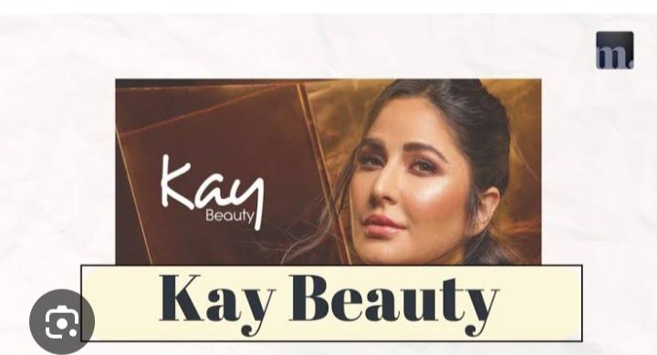

### **1. Brand Study: Kay Beauty**

**Overview:**

* **Kay Beauty** is a beauty and cosmetics brand founded by Bollywood actress **Katrina Kaif**.

**Brand Values:**

* **Inclusivity:** The products cater to a wide range of skin tones, emphasizing that beauty should be for everyone.
* **Quality:** High-quality, cruelty-free makeup with a focus on both performance and skincare.
* **Empowerment:** The brand empowers consumers to feel confident and embrace their natural beauty.

**Target Audience:**

* Primarily young women aged 18-35, interested in high-quality beauty products.
* Consumers who value cruelty-free, sustainable, and vegan products.

**Brand Tone:**

* **Authentic and Relatable:** The brand's communication is aligned with Katrina's down-to-earth and empowering persona.
* **Elegance with Simplicity:** The design and marketing focus on simplicity, with an emphasis on luxury that feels accessible.

**Positioning:**

* Positioned as an affordable yet high-quality makeup brand with a focus on inclusivity, allowing people to embrace beauty on their own terms.

### **2. Competitor Analysis**

To better understand Kay Beauty's position in the market, we need to analyze its competitors.

#### **Competitors:**

1. **Sugar Cosmetics**
   * **Target Audience:** Young women, primarily aged 18-35, who are into trendy and bold makeup.
   * **Brand Strengths:** Known for its bold colors, high-quality products, and affordable pricing.
   * **Positioning:** Aimed at young, fashion-forward Creating a buyer persona for Kay Beauty in comprehensive digital marketing involves understanding the brand’s target audience, their behaviors, preferences, and pain points. Kay Beauty, co-founded by Bollywood actress Katrina Kaif, is positioned as a premium yet accessible makeup brand known for its high-performance, skin-loving formulations.
   * Kay Beauty Buyer Persona
   * 1. Primary Target Audience Segments
   * Kay Beauty primarily targets millennial and Gen Z women in urban and semi-urban India who are beauty-conscious, socially active.
2. **MyGlamm**
   * **Target Audience:** Women aged 18-40, interested in both beauty and wellness.
   * **Brand Strengths:** Offers a variety of products, from makeup to skincare. They focus on personalization and eco-friendly solutions.
   * **Positioning:** Positioned as a brand that offers luxury at affordable prices, combining beauty with well
3. **Nykaa Beauty**
   * **Target Audience:** All age groups, including makeup enthusiasts, skincare fans, and people interested in wellness.
   * **Brand Strengths:** Established as one of India’s leading online beauty retailers. Offers a wide range of products, including makeup, skincare, and fragrances.
4. **Lakmé**
   * **Target Audience:** Broad demographic, especially women aged 18-50.
   * **Brand Strengths:** One of India’s oldest and most trusted beauty brands. Known for their makeup, skincare products, and wide range of shades.
5. **Huda Beauty (International)**
   * **Target Audience:** Women aged 18-40, beauty enthusiasts, and professionals.
   * **Brand Strengths:** Known for premium products and bold colors. Huda Beauty is often seen as a status symbol in the beauty industry.

#### **Competitive Advantages of Kay Beauty:**

* **Celebrity Endorsement:** Katrina Kaif’s presence in the brand gives it significant leverage in terms of brand recognition and credibility.
* **Inclusivity & Range:** Kay Beauty’s wide shade range for different skin tones makes it highly inclusive, which is a strong selling point.

### **3. Buyers/Audience Persona for Kay Beauty**

Creating detailed personas for Kay Beauty's target audience will help tailor the digital marketing strategies. Below are examples of audience personas:

#### **Persona 1: Priya, The Trendy College Student**

* **Age:** 22
* **Location:** Tier 1 city (Mumbai, Delhi, Bangalore)
* **Occupation:** College Student
* **Interests:** Fashion, beauty, Instagram, YouTube makeup tutorials.
* **Buying Behavior:** Buys makeup products based on influencer recommendations and social media trends. Prioritizes quality and affordability.

#### **Persona 2: Aarti, The Working Professional**

* **Age:** 30
* **Location:** Tier 1 or Tier 2 city
* **Occupation:** Marketing Manager at a tech company
* **Interests:** Fashion, health & wellness, networking events, and beauty trends.
* **Buying Behavior:** Invests in high-quality, long-lasting products. Prefers brands that are ethical and offer good value for money.

#### **Persona 3: Neha, The Beauty Enthusiast**

* **Age:** 28
* **Location:** Metro city
* **Occupation:** Beauty Blogger/Influencer
* **Interests:** Makeup, skincare, beauty vlogging, Instagram.
* **Buying Behavior:** Frequently purchases products to review and share with her followers. Highly influenced by brands with strong influencer collaborations.
* **Goals:** Wants to build a strong presence in the beauty community and offer value to her audience through honest revieiew.

### **Digital Marketing Strategies for Kay Beauty**

Based on the above insights, here’s how Kay Beauty can approach digital marketing:

#### **1. Social Media Engagement:**

* **Instagram:** Focus on influencer collaborations, beauty tutorials, user-generated content, and showcasing the inclusivity of the brand (e.g., makeup for different skin tones).
* **TikTok:** Engage in viral beauty challenges and quick tips.
* **YouTube:** Partner with beauty influencers and create how-to videos for a deeper connection with the audience.

#### **2. Content Strategy:**

* Create a content mix of beauty tips, tutorials, product launches, and behind-the-scenes footage of the brand’s creation process.
* Focus on storytelling to connect with the audience emotionally, especially leveraging Katrina Kaif’s story.

#### **3. Paid Ads:**

* Use **Facebook/Instagram Ads** to target specific demographics based on interests, behaviors, and location.

#### **4. Influencer Marketing:**

* Partner with influencers, especially micro-influencers, to build brand credibility.
* Leverage **Katrina Kaif’s** own social media presence to boost brand visibility.

#### **5. Website & E-commerce Optimization:**

* Focus on seamless user experience on Kay Beauty’s website for easy purchasing.

### **Conclusion**

Kay Beauty has a unique opportunity in the Indian beauty market, driven by its celebrity endorsement, inclusive product range, and commitment to high-quality products at affordable prices. By staying focused on these key areas and leveraging digital marketing strategies that resonate with their target audience, Kay Beauty can continue to grow its presence and engage with a broader customer base

Brand study, competitor Analysis & Buyers/Audience's persona 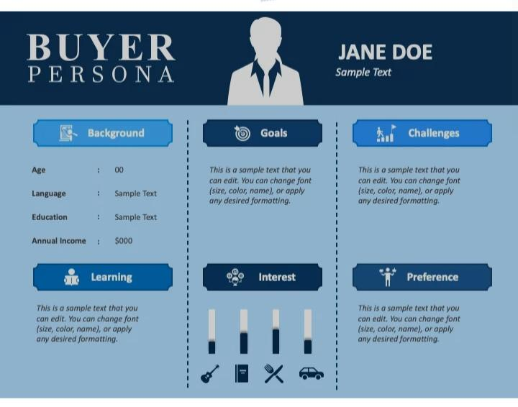

To create a comprehensive digital marketing strategy for Kay Beauty, it's important to focus on three critical areas: Brand Study, Competitor Analysis, and Buyers/Audience Persona. Here’s an in-depth look at each of these areas:

1. Brand Study: Kay Beauty

Overview:

Kay Beauty is a beauty and cosmetics brand founded by Bollywood actress Katrina Kaif.

Brand Values:

Inclusivity: The products cater to a wide range of skin tones, emphasizing that beauty should be for everyone.

Quality: High-quality, cruelty-free makeup with a focus on both performance and skincare.

Empowerment: The brand empowers consumers to feel confident and embrace their natural beauty.

Target Audience:

Primarily young women aged 18-35, interested in high-quality beauty products.

People who follow Bollywood trends and are influenced by Katrina Kaif’s image and persona.

Brand Tone:

Authentic and Relatable: The brand's communication is aligned with Katrina's down-to-earth and empowering persona.

Elegance with Simplicity: The design and marketing focus on simplicity, with an emphasis on luxury that feels accessible.

Positioning:

Positioned as an affordable yet high-quality makeup brand with a focus on inclusivity, allowing people to embrace beauty on their own terms.

2. Competitor Analysis

To better understand Kay Beauty's position in the market, we need to analyze its competitors.

Competitors:

1. Sugar Cosmetics

Target Audience: Young women, primarily aged 18-35, who are into trendy and bold makeup.

Brand Strengths: Known for its bold colors, high-quality products, and affordable pricing.

2. MyGlamm

Target Audience: Women aged 18-40, interested in both beauty and wellness.

Brand Strengths: Offers a variety of products, from makeup to skincare. They focus on personalization and eco-friendly solutions.

3. Nykaa Beauty

Target Audience: All age groups, including makeup enthusiasts, skincare fans, and people interested in wellness.

Brand Strengths: Established as one of India’s leading online beauty retailers. Offers a wide range of products, including makeup, skincare, and fragrances.

4. Lakmé

Target Audience: Broad demographic, especially women aged 18-50.

Brand Strengths: One of India’s oldest and most trusted beauty brands. Known for their makeup, skincare products, and wide range of shade.

5. Huda Beauty (International)

Target Audience: Women aged 18-40, beauty enthusiasts, and professionals.

Brand Strengths: Known for premium products and bold colors. Huda Beauty is often seen as a status symbol in the beauty industry.

with a global presence, offering innovative, high-performance products.

Competitive Advantages of Kay Beauty:

Celebrity Endorsement: Katrina Kaif’s presence in the brand gives it significant leverage in terms of brand recognition and credibility.

Inclusivity & Range: Kay Beauty’s wide shade range for different skin tones makes it highly inclusive, which is a strong selling point.

Affordability: Positioned in the mid-premium range, it offers consumers quality products at an affordable price compared to luxury brands.

3. Buyers/Audience Persona for Kay Beauty

Creating detailed personas for Kay Beauty's target audience will help tailor the digital marketing strategies. Below are examples of audience personas:

Persona 1: Priya, The Trendy College Student

Age: 22

Location: Tier 1 city (Mumbai, Delhi, Bangalore)

Occupation: College Student

Interests: Fashion, beauty, Instagram, YouTube makeup tutorials.

Buying Behavior: Buys makeup products based on influencer recommendations and social media trends. Prioritizes quality and affordability.

Goals: Wants to look fashionable without overspending. Enjoys trying out new products that help her stand out on social media.

Pain Points: Struggles with finding makeup that works for her skin tone. Prefers products that are cruelty-free and come with natural ingredients.

Persona 2: Aarti, The Working Professional

Age: 30

Location: Tier 1 or Tier 2 city

Occupation: Marketing Manager at a tech company

Interests: Fashion, health & wellness, networking events, and beauty trends.

Buying Behavior: Invests in high-quality, long-lasting products. Prefers brands that are ethical and offer good value for money.

Goals: Wants makeup that can last throughout her long working hours. Looks for products that are both professional and chic.

Pain Points: Often lacks time for makeup touch-ups. Needs products that are easy to apply and maintain their quality throughout the day.

Persona 3: Neha, The Beauty Enthusiast

Age: 28

Location: Metro city

Occupation: Beauty Blogger/Influencer

Interests: Makeup, skincare, beauty vlogging, Instagram.

Buying Behavior: Frequently purchases products to review and share with her followers. Highly influenced by brands with strong influencer collaborations.

Goals: Wants to build a strong presence in the beauty community and offer value to her audience through honest reviews.

Pain Points: Needs products that stand out in quality and packaging to make an impression with her followers.

Digital Marketing Strategies for Kay Beauty

Based on the above insights, here’s how Kay Beauty can approach digital marketing:

1. Social Media Engagement:

Instagram: Focus on influencer collaborations, beauty tutorials, user-generated content, and showcasing the inclusivity of the brand (e.g., makeup for different skin tones).

TikTok: Engage in viral beauty challenges and quick tips.

YouTube: Partner with beauty influencers and create how-to videos for a deeper connection with the audience.

2. Content Strategy:

Create a content mix of beauty tips, tutorials, product launches, and behind-the-scenes footage of the brand’s creation process.

Focus on storytelling to connect with the audience emotionally, especially leveraging Katrina Kaif’s story.

3. Paid Ads:

Use Facebook/Instagram Ads to target specific demographics based on interests, behaviors, and location.

Invest in Google Ads targeting keywords related to beauty and skincare.

4. Influencer Marketing:

Partner with influencers, especially micro-influencers, to build brand credibility.

Leverage Katrina Kaif’s own social media presence to boost brand visibility.

5. Website & E-commerce Optimization:

Focus on seamless user experience on Kay Beauty’s website for easy purchasing.

Conclusion

Kay Beauty has a unique opportunity in the Indian beauty market, driven by its celebrity endorsement, inclusive product range, and commitment to high-quality products at affordable prices. By staying focused on these key areas and leveraging digital marketing strategies that resonate with their target audience, Kay Beauty can continue to grow its presence and engage with a broader customer base.

Research brand identity

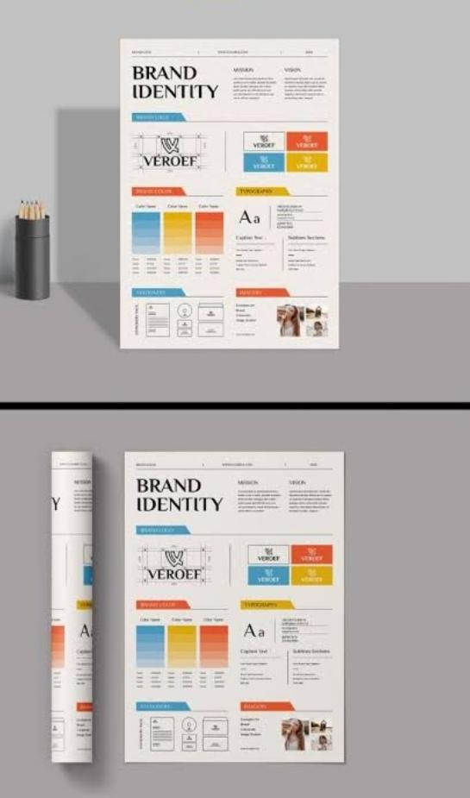

Kay Beauty, launched in 2019 by Bollywood actress Katrina Kaif, has effectively crafted a distinctive brand identity within India's competitive beauty market through strategic digital marketing initiatives.

Celebrity Endorsement and Brand Credibility

Katrina Kaif's direct involvement in Kay Beauty has significantly bolstered the brand's credibility.

Inclusivity and Empowerment Messaging

Central to Kay Beauty's ethos is its commitment to inclusivity and empowerment.

Strategic Digital Marketing and Influencer Collaborations

Kay Beauty has adeptly utilized digital marketing by collaborating with a diverse array of influencers across social media platforms.

Expansion and Accessibility

Initially focusing on e-commerce, Kay Beauty expanded its reach by partnering with leading beauty retailers like Nykaa, ensuring accessibility across India. The brand's products are available in over 90 Nykaa stores nationwide, delivering to more than 1,600 cities, and have also launched in international markets like Dubai.

Community Engagement and Corporate Social Responsibility (CSR)

CBeyond products, Kay Beauty has launched initiatives like 'KARE' to give back to the community.

Visual Identity and Branding

The Kay Beauty logo embodies elegance and simplicity, aligning with the brand's modern and inclusive image.

Conclusion

Through a combination of strategic digital marketing, influencer collaborations, a focus on inclusivity, and community engagement, Kay Beauty has established a strong and authentic brand identity. These efforts have positioned the brand as a relatable and aspirational choice for consumers, contributing to its growth and success in the beauty industry.

Competitor Analysis

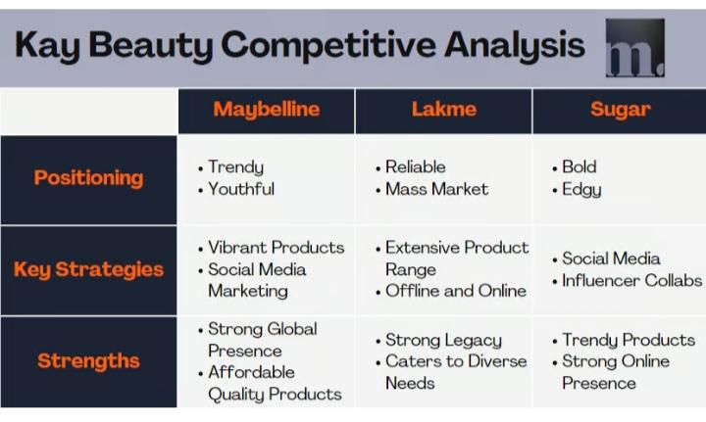

Competitor Strategies in Digital Marketing

To understand Kay Beauty's positioning, it's essential to examine the digital marketing approaches of its competitors:

1. CoverGirl: This established brand has rejuvenated its image by heavily investing in social media influencers.

2. Kylie Cosmetics: Founded by Kylie Jenner, the brand leverages her massive social media following to drive engagement.

3. Procter & Gamble (P&G): To counteract sales declines, P&G has intensified its focus on digital platforms like China's Douyin (TikTok).

Key Takeaways for Kay Beauty

Influencer Collaborations: Partnering with influencers across various demographics can enhance brand reach and authenticity.

Platform Diversification: Expanding presence on emerging platforms and utilizing features like Instagram Reels and YouTube Shorts can capture a broader audience.

Authentic Content: Sharing behind-the-scenes content and user-generated posts fosters a genuine connection with the audience.

By analyzing and adapting these strategies, Kay Beauty can continue to strengthen its position in the competitive beauty market

Buyer's Audience's persona

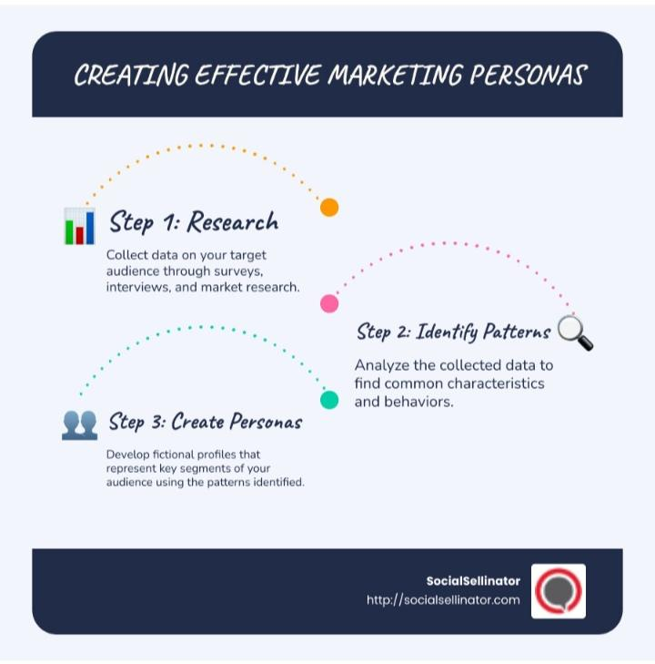

* Creating a buyer’s audience persona for Kay Beauty in comprehensive digital marketing involves understanding the brand’s target audience, their behaviors, preferences, and motivations. Kay Beauty, co-founded by Katrina Kaif, is positioned as a premium yet accessible beauty brand in India, focusing on high-performance, long-lasting, and skin-loving makeup.

1. Primary Audience Persona (Core Consumer)

Name: Priya Sharma

Age: 22-35 years

Gender: Predominantly Female (but inclusive of all genders interested in beauty)

Location: Metro & Tier 1 cities (Mumbai, Delhi, Bangalore, Kolkata, Hyderabad, Chennai)

Occupation: Young professionals, influencers, students, and working women

Income Level: Middle to upper-middle class

Education: College-educated, career-driven

Personality: Confident, trendy, ambitious, and socially activ

Pain Points:

Wants high-quality makeup at a reasonable price

Seeks long-lasting, sweat-proof, and Indian-weather-friendly makeup

Digital Behavior:

Active on Instagram, YouTube, Pinterest, and beauty blogs

Engages in influencer-led brand promotions and tutorials

2. Secondary Audience Persona (Aspiring Beauty Enthusiast)

Name: Aditi Verma

Age: 18-25 years

Gender: Female & Non-Binary Beauty Enthusiasts

Location: Tier 2 & 3 Cities (Jaipur, Lucknow, Chandigarh, Indore, Pune)

Occupation: College students, young professionals

Income Level: Budget-conscious but aspirational

Education: College-goers, entry-level professionals

Psychographics & Interests:

Looks up to celebrities and influencers for beauty tips

Loves experimenting with makeup trends but seeks affordability

Uses social media to learn makeup skills (Instagram Reels, YouTube Shorts)

Engages in price-sensitive shopping but aspires for premium-quality products

Pain Points:

Limited access to premium beauty stores in smaller cities

Prefers budget-friendly but high-performing makeup

Needs tutorials for makeup application due to limited offline access to experts

Digital Behavior:

Active on Instagram, Facebook, and YouTube

Engages in giveaway contests and discount-driven marketing campaigns

Frequently shops online during sales (Nykaa, Amazon Beauty)

Relies heavily on influencer reviews and recommendation

1. Social Media Engagement:

Instagram Reels & YouTube Shorts featuring beauty hacks, tutorials, and transformations

Celebrity-led campaigns with Katrina Kaif and influencers

Hashtag campaigns like #KayBeautyLooks or #MakeupThatKares

2. Influencer Collaborations:

Partnering with micro-influencers for authentic reviews in Tier 2 & 3 cities

Premium influencers for luxury beauty shoppe.

By aligning digital marketing efforts with these audience personas, Kay Beauty can strengthen its brand presence, enhance customer engagement, and drive sales effectively.

SEO & keyword Reasearch

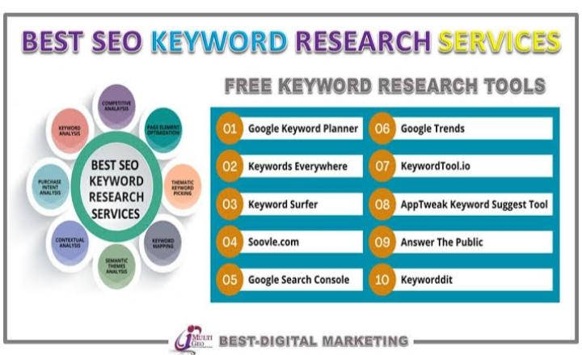

SEO & Keyword Research in Digital Marketing for Kay Beauty

Kay Beauty, as a premium beauty brand, needs a strong SEO and keyword strategy to enhance its digital presence, drive traffic, and boost conversions. Here’s a comprehensive approach:

---

1. Keyword Research for Kay Beauty

a) Identifying Core Keywords

Branded Keywords: "Kay Beauty products," "Kay Beauty lipstick," "Kay Beauty foundation," etc.

Product-Specific Keywords: "matte lipsticks India," "best waterproof kajal," "long-lasting foundation," etc.

Intent-Based Keywords:

Informational: "how to apply matte lipstick," "best makeup for oily skin"

Navigational: "Kay Beauty official website," "buy Kay Beauty online"

Transactional: "Kay Beauty sale," "Kay Beauty lipstick price," "buy Kay Beauty kajal"

b) Long-Tail Keywords (High Intent & Less Competition)

“best lipstick for Indian skin tone”

“Kay Beauty hydrating foundation reviews”

“smudge-proof eyeliner for monsoon”

c) Competitor Analysis for Keywords

Research competitor brands (e.g., Lakme, Maybelline, Sugar Cosmetics)

Use SEMrush, Ahrefs, or Google Keyword Planner to analyze high-performing keywords

---

2. On-Page SEO for Kay Beauty Website

a) Title & Meta Descriptions Optimization

Titles: "Kay Beauty Lipsticks | Smudge-Proof & Long-Lasting – Shop Now"

Meta: "Explore Kay Beauty’s range of high-performance makeup—cruelty-free, long-lasting, and made for Indian skin tones."

b) URL Structure

Example: https://www.kaybeauty.com/matte-lipstick (SEO-friendly, no unnecessary characters)

c) Content Optimization

Use primary & secondary keywords naturally in product descriptions, blogs, and landing pages

Add FAQ sections targeting common queries ("Is Kay Beauty cruelty-free?" etc.)

d) Image Optimization

Use alt tags like "Kay Beauty red lipstick swatch"

Compress images for fast loading speed

e) Internal Linking Strategy

Blog: "Best Nude Lipsticks for Everyday Wear" → Link to relevant product pages

---

3. Technical SEO for Better Rankings

Mobile Optimization: Ensure site is mobile-friendly & loads fast

Site Speed: Optimize images, enable lazy loading, use a CDN

Structured Data Markup: Add schema for product reviews, prices, and FAQs

---

4. Off-Page SEO: Building Authority

a) Backlink Strategy

Partner with beauty bloggers & influencers for guest posts

Get features on high-authority sites (Vogue, Nykaa, Femina)

Collaborate with YouTube influencers for review videos & backlinks

b) Social Media SEO

Optimize Instagram & YouTube descriptions with keywords & hashtags

Example: #KayBeautyIndia #LongLastingLipstick #MakeupForIndianSkin

---

5. Local SEO for Retail Presence

Google My Business Optimization

Add store locations, photos, working hours

Encourage customers to leave reviews on Google

Conclusion

By implementing a strong SEO & keyword research strategy, Kay Beauty can enhance its online visibility, attract high-intent customers, and drive conversions. A mix of on-page, off-page, and technical SEO along with content marketing & influencer collaborations will ensure long-term growth in the beauty segment.

SEO Audit

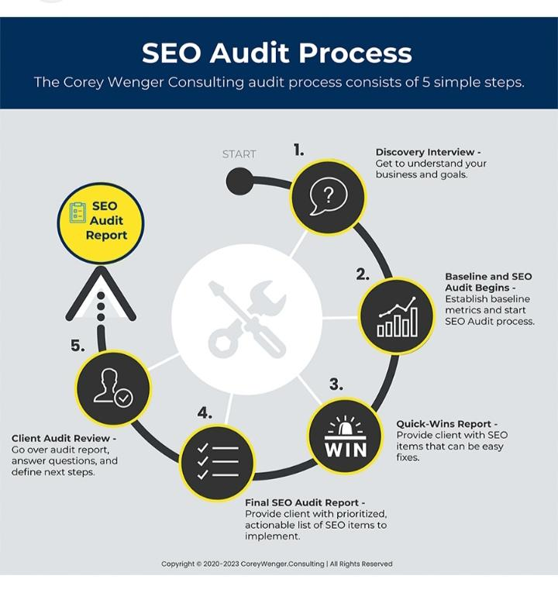

Conducting an SEO audit for Kay Beauty (or any beauty brand) as part of a comprehensive digital marketing strategy involves analyzing various factors to improve organic search visibility and performance. Here's a detailed breakdown:

---

1. Website Audit

Technical SEO:

✔ Site Speed & Performance: Check loading times using tools like Google PageSpeed Insights.

✔ Mobile Friendliness: Ensure a responsive design and mobile usability.

✔ Indexability & Crawlability: Use Google Search Console to check for errors, sitemaps, and robots.txt issues.

✔ HTTPS Security: Ensure SSL certification for secure browsing.

✔ Broken Links & Redirects: Identify 404 errors and unnecessary redirects.

On-Page SEO:

✔ Keyword Optimization: Identify high-ranking beauty-related keywords (e.g., “best long-lasting lipstick in India”).

✔ Title Tags & Meta Descriptions: Optimize for click-through rate (CTR).

✔ Content Structure: Use H1, H2, and H3 headers properly.

✔ Image Optimization: Use compressed images with descriptive alt tags.

---

2. Content Strategy & SEO

✔ Blog Optimization: Publish engaging, keyword-rich content (e.g., “How to Choose the Perfect Nude Lipstick”).

✔ Product Page Optimization: Use detailed descriptions, rich media, and customer reviews.

✔ Internal Linking: Ensure related articles and product pages are interlinked.

✔ User Intent Alignment: Optimize content for informational, navigational, and transactional queries.

---

3. Off-Page SEO & Backlink Analysis

✔ Backlink Quality: Analyze referring domains and remove toxic links.

✔ Influencer Collaborations: Partner with beauty bloggers for guest posts and mentions.

✔ PR & Digital Outreach: Gain backlinks from high-authority beauty and fashion websites.

✔ Social Signals: Encourage sharing on Instagram, YouTube, and Pinterest.

---

4. Local SEO (If Applicable)

✔ Google My Business (GMB) Optimization: Optimize store locations, reviews, and business details.

✔ Local Directories: Ensure consistent NAP (Name, Address, Phone) information.

✔ Local Keywords: Optimize for location-based searches (e.g., “best matte lipstick in Mumbai”).

5. Technical & Performance Enhancements

✔ Schema Markup: Implement structured data for rich snippets (e.g., product ratings, FAQ schema).

✔ Core Web Vitals: Optimize LCP (Largest Contentful Paint), FID (First Input Delay), and CLS (Cumulative Layout Shift).

✔ Canonical Tags: Avoid duplicate content issues.

Keyword Reasearch



Effective keyword research for Kay Beauty (or any beauty brand) helps improve organic search visibility, drive traffic, and enhance conversions. The process involves identifying high-intent, trending, and competitive keywords that align with Kay Beauty’s product categories, audience interests, and brand positioning.

---

1. Define Keyword Goals & Categories

Kay Beauty’s keyword strategy should focus on:

✅ Branded Keywords – People searching directly for "Kay Beauty" products.

✅ Product-Specific Keywords – Keywords for makeup items like lipsticks, foundations, etc.

✅ Category-Based Keywords – Keywords related to beauty trends and cosmetics.

✅ Problem-Solving Keywords – Search queries related to common beauty concerns.

✅ Transactional Keywords – High-conversion keywords where users are ready to buy.

✅ Informational Keywords – Educational searches like makeup tutorials and tips.

--

2. Tools for Keyword Research

Google Keyword Planner (for volume & competition)

Ahrefs / SEMrush (for competitor analysis & keyword gaps)

Google Search Console (to analyze current rankings)

Ubersuggest (to find long-tail keywords)

Pinterest & YouTube SEO (for beauty trend-based keywords)

---

3. Sample Keywords for Kay Beauty

(A) Branded Keywords

Kay Beauty lipstick

Kay Beauty foundation shades

Kay Beauty reviews

Buy Kay Beauty online

Kay Beauty vs Sugar Cosmetics

(B) Product-Specific Keywords

Long-lasting lipstick for dry lips

Best foundation for Indian skin

Waterproof kajal for sensitive eyes

Matte vs. glossy lipsticks

Kay Beauty blush shades

(C) Category-Based Keywords

Best cruelty-free makeup brands in India

Affordable makeup for oily skin

Best nude lipstick for Indian skin tone

Trending makeup looks 2025

Smudge-proof kajal under ₹500

(D) Problem-Solving Keywords

How to prevent lipstick from smudging

Best foundation for acne-prone skin

How to apply concealer correctly

Best makeup products for humid weather

Makeup tips for beginners

(E) Transactional Keywords

Buy waterproof eyeliner online

Best foundation under ₹1000

Discount on Kay Beauty products

Nykaa sale on Kay Beauty

Where to buy Kay Beauty in Mumbai

(F) Informational Keywords (Blog & YouTube SEO)

Step-by-step smokey eye tutorial

How to choose the right lipstick shade

What is the best primer for oily skin?

Kay Beauty product swatches & reviews

Makeup hacks every girl should know

---

4. Competitor Keyword Research

Analyzing competitors like:

Nykaa Beauty

Sugar Cosmetics

Lakmé

Maybelline India

MAC India

On page optimization

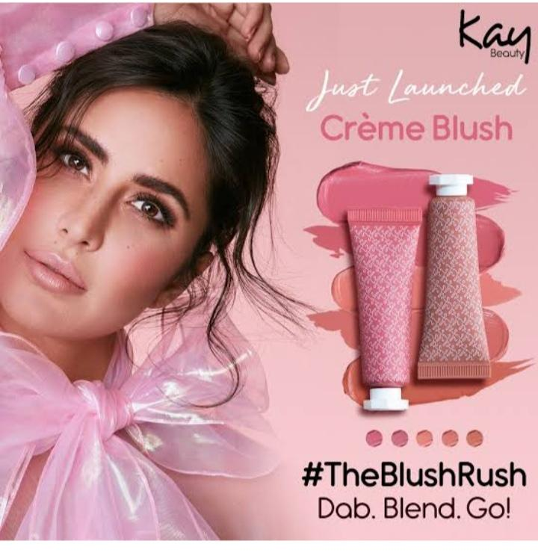

On-Page Optimization for Kay Beauty in Comprehensive Digital Marketing

On-page optimization is crucial for enhancing Kay Beauty’s online visibility, driving organic traffic, and improving search engine rankings. Below is a detailed breakdown of on-page optimization strategies tailored for Kay Beauty in a comprehensive digital marketing approach.

---

1. Keyword Optimization

Conduct keyword research targeting beauty, skincare, and makeup-related terms.

Focus on high-search volume and low-competition keywords like:

"Best long-lasting foundation in India"

"Cruelty-free lipsticks for Indian skin tones"

"Kay Beauty hydrating concealer review"

Optimize title tags, meta descriptions, headers (H1, H2, H3), and content with these keywords.

---

2. SEO-Friendly URL Structure

Ensure URLs are short, clean, and keyword-rich:

✅ www.kaybeauty.com/best-matte-lipsticks

❌ www.kaybeauty.com/product1234?=lipstick

---

3. Content Optimization

Create high-quality, engaging, and informative content.

Leverage:

Product descriptions optimized for SEO.

How-to guides & beauty tutorials (e.g., "How to Achieve the Perfect Nude Makeup Look with Kay Beauty").

Customer reviews & testimonials for credibility.

---

4. Image & Video Optimization

Use high-quality product images with proper alt tags (e.g., "Kay Beauty Matte Liquid Lipstick Swatch").

Optimize file sizes for faster loading speed.

Include video tutorials and influencer testimonials.

---

5. Internal Linking Strategy

Link relevant product pages and blog posts.

Example:

A blog on "Best Foundation for Dry Skin" should link to Kay Beauty Hydrating Foundation product page

By implementing these on-page SEO strategies, Kay Beauty can significantly improve its search rankings, organic traffic, and conversion rates while strengthening its digital presence in the beauty industry.

Content Ideas And marketing strategies

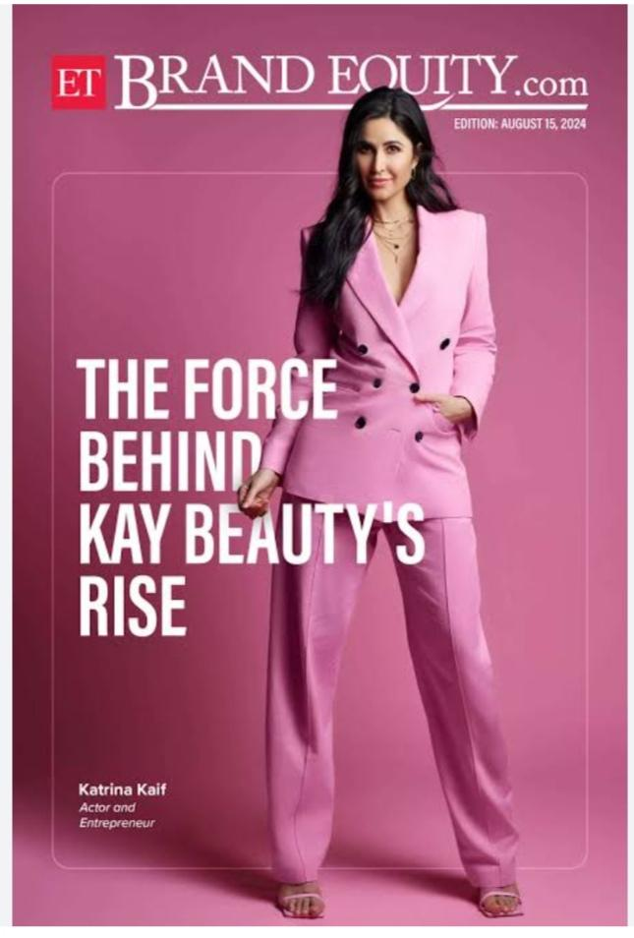

Kay Beauty, as a beauty brand, can benefit from a well-rounded digital marketing strategy that includes content marketing, influencer collaborations, and performance-driven campaigns. Here’s a breakdown of content ideas and marketing strategies:

---

Content Ideas for Kay Beauty

1. Educational & Value-Based Content

Makeup Tutorials: Step-by-step guides featuring Kay Beauty products for different skin tones, occasions, and styles.

Ingredient Breakdown: Explain the benefits of key ingredients in products (e.g., "Why Hyaluronic Acid is a Game Changer for Your Skin").

Makeup Hacks & Pro Tips: Quick, engaging reels showcasing unique ways to use Kay Beauty products.

Skin & Makeup Routine: Feature morning/evening beauty routines incorporating Kay Beauty products.

2. User-Generated Content (UGC)

Customer Transformations: Before-and-after shots using Kay Beauty products.

Real Reviews: Share testimonials in an engaging format (e.g., "Swipe to See What Our Customers Say").

Community Challenges: Create hashtag challenges (e.g., #KayGlowChallenge) to encourage followers to post their looks.

3. Celebrity & Influencer Collaborations

Katrina Kaif’s Beauty Secrets: Leverage the brand’s association with Katrina Kaif by sharing her favorite products and tips.

Influencer Takeovers: Let beauty influencers take over Kay Beauty’s Instagram Stories for a day to showcase products.

Collaboration with Makeup Artists: Have professional MUAs create signature looks using Kay Beauty.

4. Seasonal & Trend-Based Content

Festival Makeup Looks: Diwali, Christmas, Eid, and wedding season makeup guides.

Trending Beauty Challenges: Participate in viral TikTok and Instagram trends featuring Kay Beauty products.

Summer/Winter Makeup Essentials: Feature products suitable for different seasons.

5. Lifestyle & Wellness Content

Beauty & Wellness Connection: Content on skincare, self-care, and holistic beauty.

Behind the Scenes (BTS): Show the making of Kay Beauty products, team stories, or sustainability efforts.

Day in the Life: Feature influencers, employees, or Katrina Kaif using the products throughout the day.

---

Marketing Strategies for Kay Beauty

1. Social Media Marketing

Instagram & TikTok Reels: Short, engaging videos showcasing product application and results.

YouTube Beauty Series: Create a dedicated series featuring makeup tutorials, Q&As, and expert tips.

Pinterest Boards: Curate inspiration boards for different makeup looks.

Interactive Polls & Q&A: Engage the audience with Instagram Stories and Twitter polls.

2. Influencer & Celebrity Marketing

Micro & Macro Influencers: Collaborate with beauty influencers across different demographics.

Celebrity Partnerships: Have Katrina Kaif share exclusive content and tutorials.

Affiliate Programs: Offer commissions for influencers promoting Kay Beauty.

3. SEO & Content Marketing

Beauty Blog: Publish articles on trending beauty topics, makeup guides, and skincare advice.

Keyword Optimization: Optimize website content with beauty-related keywords for organic reach.

YouTube SEO: Use optimized video titles, descriptions, and tags to boost discoverabilit

Content Ideas Generation & strategies

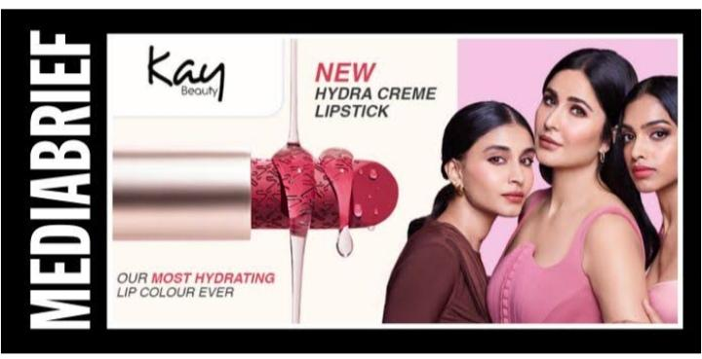

Creating a strong content strategy for Kay Beauty (or any beauty brand) in comprehensive digital marketing involves leveraging multiple platforms, engaging storytelling, and value-driven content. Here are some ideas:

---

1. Content Pillars & Themes

A. Product-Centric Content

Tutorials & How-Tos: “5-Minute Everyday Makeup with Kay Beauty”

Before & After Transformations: Using foundation, concealers, etc.

Product Spotlights: Breakdown of ingredients, benefits, & shade guides

User-Generated Content (UGC): Reposting influencer & customer videos

B. Educational & Value-Based Content

Makeup Tips & Hacks: “How to Make Your Makeup Last All Day”

Skin & Makeup Compatibility: "Best Kay Beauty Products for Oily Skin"

Ingredient Deep Dives: Explaining the benefits of Vitamin C, Hyaluronic Acid, etc.

Sustainability & Clean Beauty: Showcasing eco-friendly practices

C. Trend & Pop Culture-Driven Content

Viral Beauty Trends: “Glass Skin Look with Kay Beauty”

Seasonal Trends: "Monsoon-Proof Makeup Routine"

Makeup Looks Inspired by Celebs or Events: “Recreating Katrina Kaif’s Red Carpet Look”

D. Brand Storytelling & Community Building

Behind the Scenes (BTS): Factory tours, packaging process, Katrina’s involvement

Meet the Founder: Katrina Kaif’s vision & philosophy for the brand

Customer Stories: Featuring real customers & their journeys

Brand Collaborations: Partnering with beauty influencers & experts

---

2. Digital Marketing Strategies

A. Social Media Content Strategy

Instagram & TikTok (Reels/Shorts): Quick, engaging tutorials, trend-driven videos

Pinterest & YouTube: Long-form makeup guides, mood boards

Twitter & Threads: Quick beauty tips, brand updates, AMAs

Facebook Groups & Communities: “Kay Beauty Lovers” for engagement

B. Influencer & UGC Campaigns

Micro & Macro Influencers: Collaborate with diverse influencers

Challenges & Contests: “Show Your Glow with Kay Beauty” challenge

Brand Ambassador Programs: Loyal customers & influencers

C. SEO & Blog Content

SEO-Optimized Blog Posts: "Best Foundations for Indian Skin Tones"

How-to Guides: "How to Achieve a Dewy Look with Kay Beauty"

Comparisons: "Kay Beauty vs. Other Drugstore Brands"

Marketing strategies

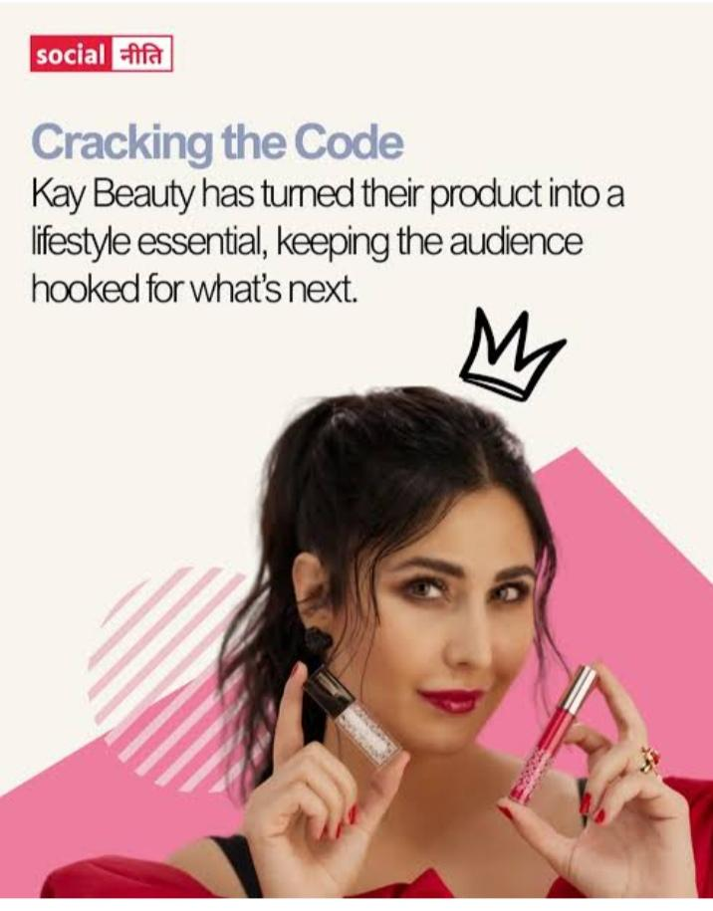

To create a comprehensive digital marketing strategy for Kay Beauty, we need to focus on multiple digital channels to enhance brand awareness, engagement, and sales. Here’s a structured plan:

1. Social Media Marketing (SMM)

Kay Beauty is already strong on Instagram and YouTube, but it can further enhance its reach by:

Instagram & Facebook:

Leverage reels, carousels, and influencer collaborations to showcase products.

YouTube & Shorts:

Publish in-depth beauty tutorials, celebrity-endorsed content, and behind-the-scenes videos.

Collaborate with influencers for unboxing and first-impression videos.

TikTok & Snapchat:

Launch branded challenges (e.g., #KayGlowChallenge) to increase organic reach.

Use short, engaging product demos.

2. Influencer & Celebrity Marketing

Micro & Macro Influencers: Partner with beauty bloggers and makeup artists for authentic reviews.

Bollywood & Beauty Icons: Expand endorsements beyond Katrina Kaif, featuring other celebrities.

Affiliate Programs: Offer commissions to beauty influencers to drive sales.

3. Content Marketing & SEO

Blog Strategy:

Write SEO-optimized blogs on beauty tips, skincare routines, and makeup hacks.

Use long-tail keywords like "best foundation for Indian skin tone" for Google ranking.

Video Content:

Create "How-To" makeup videos (e.g., festive looks, office makeup, wedding glam).

Share BTS (Behind-the-Scenes) videos of product formulation.

4. Paid Digital Advertising (PPC & Social Ads)

Google Ads:

Target beauty-related searches with Google Search & Shopping Ads.

Use Display Ads on beauty blogs and websites.

Meta (Facebook & Instagram) Ads:

Run carousel ads showcasing before/after transformations.

Use retargeting ads for abandoned carts.

YouTube & TikTok Ads:

Short, compelling ads featuring Katrina Kaif.

Target beauty enthusiasts and makeup shoppers.

5. Email & SMS Marketing

Personalized Campaigns:

Send newsletters with beauty tips, offers, and new launches.

Use AI-driven recommendations based on customer behavior.

Exclusive Offers & Early Access:

Give loyal customers first access to limited-edition products.

Offer discounts during festive seasons.

6. E-Commerce & Website Optimization

SEO & UI/UX Improvements:

Optimize product pages with high-quality images, reviews, and videos.

Implement AI-driven virtual try-ons for lipsticks and foundations.

D2C Growth Strategy:

Reduce reliance on Nykaa/Amazon by enhancing Kay Beauty’s official website sales.

Offer free shipping and loyalty rewards.

7. Community Engagement & PR Groups & Beauty Forums:

Create a "Kay Beauty Club" for customers to share makeup looks and tips.

Encourage engagement through contests and giveawaysntent Calendar*

1. *Monthly Themes*: Focus on specific themes (e.g., summer skincare, holiday makeup)

2. *Weekly Content*: Publish new content on a weekly basis (blog posts, videos, social media posts)

3. *Daily Engagement*: Engage with followers on social media through daily posts, stories, and comments

Content Creation:

*Blog Posts*

1. *Beauty Trends*: Write about the latest beauty trends, including makeup, skincare, and haircare

2. *Product Reviews*: Review Kay Beauty products and provide honest feedback

1. *Makeup Tutorials*: Create step-by-step makeup tutorials using Kay Beauty products

2. *Product Demos*: Demonstrate the features and benefits of Kay Beauty products

*Social Media Posts*

1. *Product Showcase*: Showcase Kay Beauty products through high-quality images and videos

2. *Behind-the-Scenes*: Share behind-the-scenes content, including product development, photoshoots, and company events

Content Curation:

*Sources*

1. *Beauty Blogs*: Curate content from popular beauty blogs and websites

2. *Social Media*: Curate content from social media platforms, including Instagram, Facebook, and Twitter's

Post creation

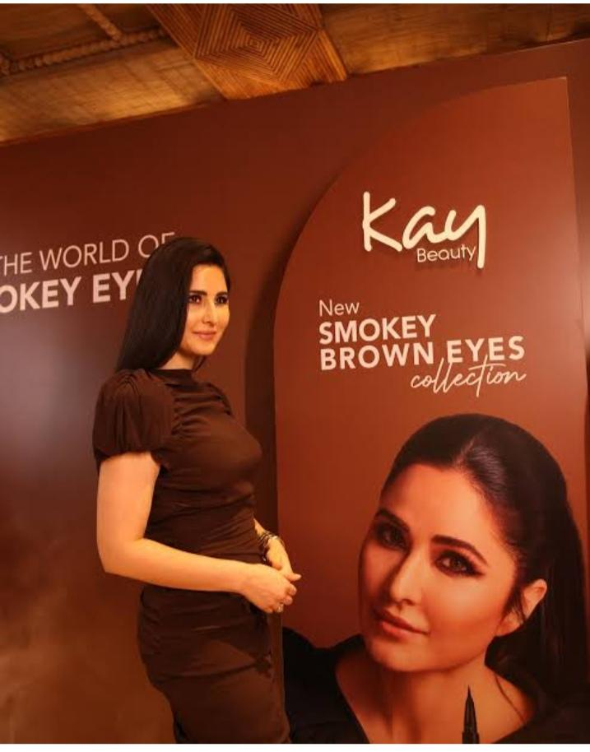

Here's a post creation plan for Kay Beauty:

Post Types:

1. *Product Showcase*: Highlight a specific product, its features, and benefits.

2. *Before-and-After*: Share dramatic before-and-after photos or videos of customers who have used Kay Beauty products.

3. *Makeup Tutorial*: Create step-by-step makeup tutorials using Kay Beauty products.

4. *Skincare Routine*: Share a skincare routine using Kay Beauty products and provide tips on how to achieve healthy, glowing skin.

5. *Customer Testimonial*: Share customer testimonials and reviews of Kay Beauty products.

6. *Behind-the-Scenes*: Give a sneak peek into the making of Kay Beauty products, company events, or photoshoots.

7. *Q&A*: Host a Q&A session on social media, answering customer questions and providing beauty tips.

8. *Product Demonstration*: Demonstrate the features and benefits of Kay Beauty products through videos or live streams.

9. *Influencer Takeover*: Invite an influencer to take over Kay Beauty's social media accounts for a day.

10. *Special Promotion*: Create a post announcing a special promotion, discount, or giveaway.

Post Format:

1. *Image Post*: Share high-quality images of Kay Beauty products, customers, or company events.

2. *Video Post*: Share videos showcasing Kay Beauty products, makeup tutorials, or company events.

3. *Carousel Post*: Share a series of images or videos showcasing Kay Beauty products, customer testimonials, or company event

Post Schedule:

1. *Monday*: Motivation Monday - Share a motivational quote or message to kick-start the week.

2. *Tuesday*: Tip Tuesday - Share a beauty tip or trick using Kay Beauty products.

3. *Wednesday*: Wednesday Wisdom - Share a blog post or article on beauty trends, skincare routines, or makeup techniques.

Post Creation Tools:

1. *Adobe Creative Cloud*: Use Adobe Creative Cloud to create high-quality images and videos.

2. *Canva*: Use Canva to create social media graphics, blog posts, and email newsletter

Post Optimization:

1. *Use Relevant Hashtags*: Use relevant hashtags to increase the visibility of Kay Beauty's social media posts.

2. *Tag Relevant Accounts*: Tag relevant accounts, such as influencers, beauty bloggers, or other beauty brands, to increase engagement and reach

Social Media Ad Campaigns

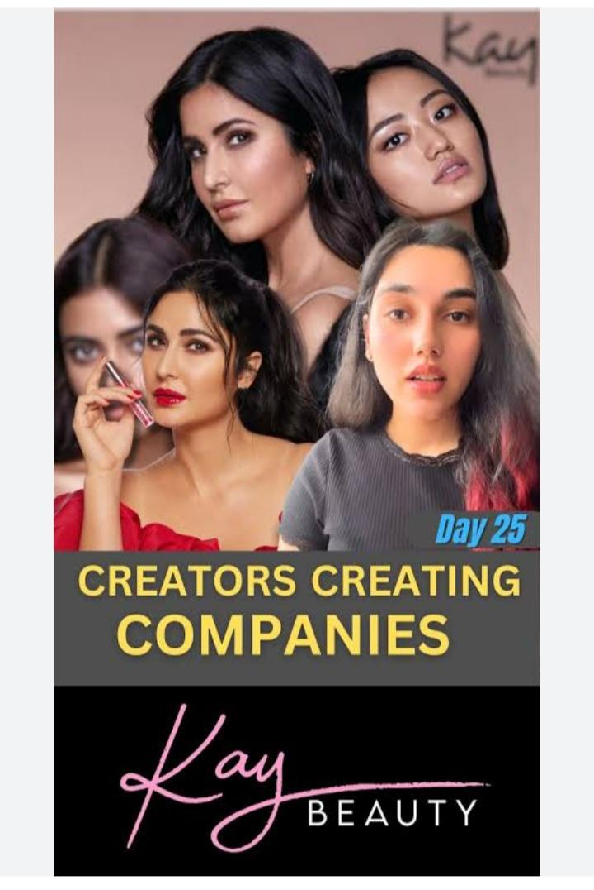

Come up with 3 ad campaigns each covering one of the mentioned goals: brand awareness, driving website traffic, or generating leads

For every campaign clearly define:

Advertising Goals: increasing brand awareness, driving website traffic, or generating leads.

Audience Targeting:

Here are three social media ad campaigns tailored for the Kay Beauty industry, each focusing on a different advertising goal:

---

Campaign 1: “Glow With Confidence” – Brand Awareness

Advertising Goal:

Increase brand awareness by introducing the audience to the unique selling points of the brand (clean ingredients, long-lasting formula, or inclusive shade range).

Audience Targeting:

Demographics: Women, ages 18-35

Interests: Beauty enthusiasts, makeup lovers, skincare-conscious individuals

Behavior: Engages with beauty influencers, follows makeup brands, watches beauty tutorials

Ad Creation:

Visuals: A short reel or carousel featuring influencers or diverse models applying the product, highlighting its features (e.g., swatches, texture, and finish).

Ad Copy:

"Glow with confidence! Meet [Brand Name]—the beauty revolution that enhances your natural radiance. Our clean, long-lasting formulas are made for every skin tone.

Call-to-Action (CTA): “Follow us & explore the future of beauty!”

Campaign 2: “Your Perfect Shade, Just a Click Away” – Driving Website Traffic

Advertising Goal:

Encourage potential customers to visit the website and explore products.

Audience Targeting:

Demographics: Women, 20-40 years old

Interests: Online shoppers, beauty product explorers, sustainable beauty lovers

Behavior: Engages with online beauty stores, reads product reviews, searches for “best foundation for [skin type]”

Ad Creation:

Visuals: A carousel ad showcasing different shades and finishes, with an interactive element (swipe to find your match).

Ad Copy:

"Struggling to find your perfect shade? Our AI-powered shade finder makes it easy! Swipe through our bestsellers and discover your ideal match—effortless beauty at your fingertips."

CTA: “Find Your Shade Now →” (leading to the website’s shade finder page)

---

Campaign 3: “Exclusive VIP Beauty Club” – Generating Leads

Advertising Goal:

Collect leads by encouraging users to sign up for an exclusive beauty membership (discounts, early access, free samples).

Audience Targeting:

Demographics: Women, 25-45 years old

Interests: Luxury beauty, makeup tutorials, skincare routine

Email Ad compaings



Here are two email ad campaigns tailored for the Kay Beauty industry, focusing on brand awareness and lead generation:

---

Campaign 1: Brand Awareness – "Discover the Magic of Kay Beauty"

Goal: Increase brand visibility and engagement with potential customers

1. Email List:

Target audience:

Beauty enthusiasts who follow skincare and makeup trends

Subscribers from social media contests/giveaways

Influencers and beauty bloggers

Customers who signed up for newsletters but haven’t made a purchase

Past customers who haven’t engaged in the last 3-6 months

List-building methods:

Social media sign-up forms (Instagram, TikTok, Facebook)

Collaborations with influencers who share email sign-up links

Blog readers (opt-in on beauty guides or trend reports)

Freebie incentives like "Get a free beauty guide when you sign up!"

2. Email Content:

Subject Line: ✨ Unveil Your Glow: Meet Kay Beauty!

Header: Your Beauty, Your Way – The Kay Beauty Difference

Body:

Introduce Kay Beauty, its unique selling points (e.g., clean ingredients, trend-forward products, inclusivity). Include a video tutorial or influencer testimonial.

Offer an exclusive discount (10% off on the first purchase) to encourage engagement.

CTA (Call to Action): "Claim Your Welcome Gift" (Leads to landing page with a discount code)

---

3. Performance Measurement:

Open Rate: To measure interest in the subject line

Click-through Rate (CTR): To track engagement with the content and CTA

Social Media Engagement: Monitor if the email leads to new social follows or shares

Redemption Rate: Track how many people use the discount code

---

Campaign 2: Lead Generation – "Exclusive Beauty Insider Access"

Goal: Capture high-quality leads by offering value-based content

1. Email List:

Target audience:

New website visitors who abandon the cart

Users who interacted with product quizzes or recommendations

Attendees from beauty masterclasses or online events

People who engage with beauty content (webinars, tutorials)

List-building methods:

Exit-intent popups offering a free beauty guide

Product quiz results sent via email in exchange for an email sign-up

Partnerships with beauty influencers for lead generation (sign-up to get a “beauty secret” PDF)

Referral campaigns (e.g., “Invite a friend & get an exclusive beauty gift!”)

2. Email Content:

Subject Line: ✨ Your Personalized Beauty Secrets Are Inside!

Header: Unlock Insider Tips & Special Perks

Body:

Encourage sign-ups for an exclusive "Beauty Insider Club" that gives access to personalized recommendations, early product launches, and VIP discounts.

Include a sneak peek of valuable content, such as a skincare guide or an exclusive beauty masterclass.

CTA: "Join the Beauty Insider Club Normal

Design vedio Editing

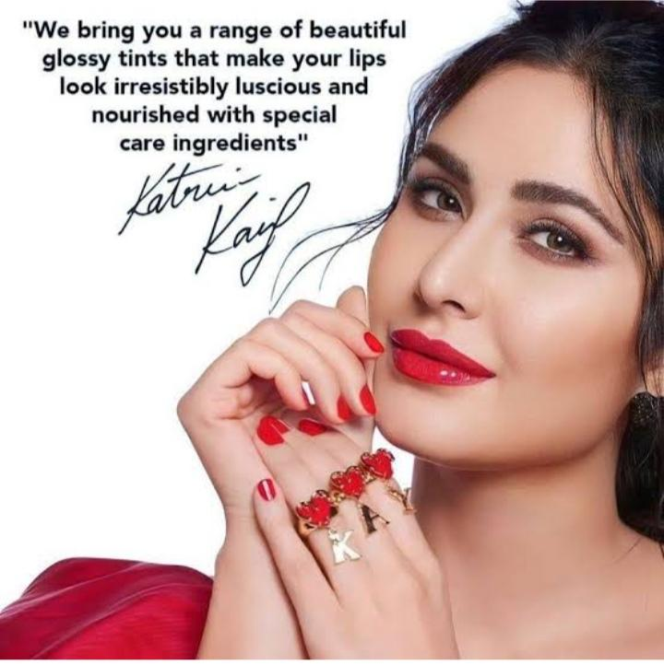

For Kay Beauty designs and video editing, maintain a premium and minimal aesthetic with soft lighting, smooth transitions, and high-resolution visuals. Focus on:

Color Palette: Nude, warm, and elegant tones.

Typography: Bold yet sophisticated fonts for text overlays.

Editing Style: Seamless transitions, slow-motion swatch reveals, and close-up shots.

Effects: Subtle glows, speed ramps, and motion graphics for an engaging feel.

Trendy Formats: Instagram Reels, TikToks, and YouTube Shorts with engaging music.

Keep it visually appealing and on-brand to attract beauty lovers!